Spring Boot with Apache Kafka | Simple Programming

<https://www.youtube.com/watch?v=gdo_AMfncpU&index=17&list=PLO0KWyajXMh4fGMvAw1yQ1x7mWayRcmX3>

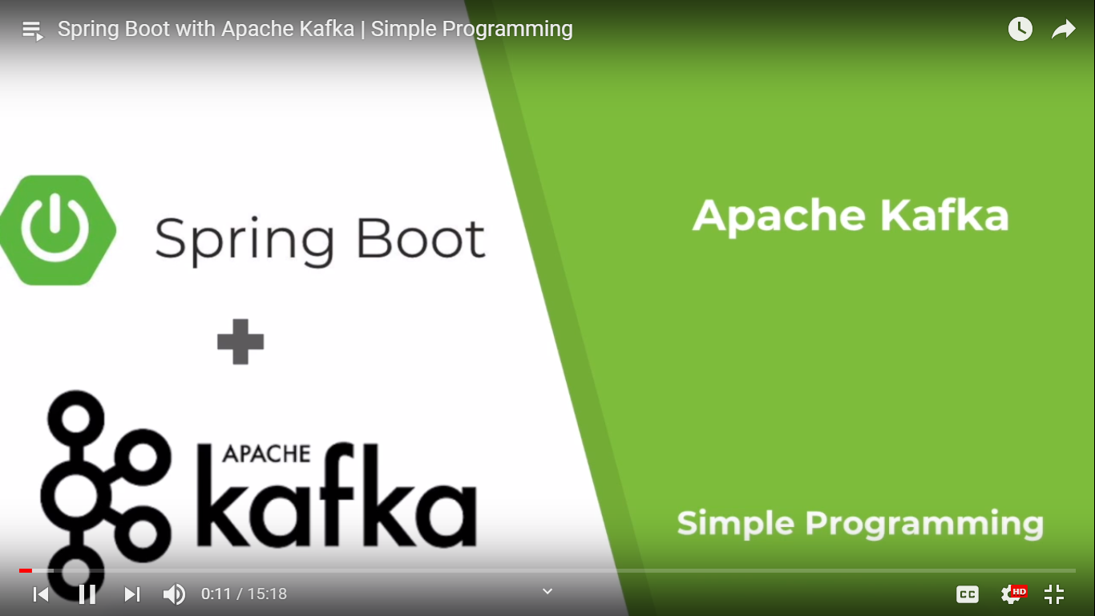

Kafka as a messaging service. It is a distributed publisher subscriber messaging system which can handle large volume of data.

It has high reliability and can be scaled easily.

It is fault tolerance because the messages are persistent in the disc before sending to the consumer to prevent data loss.

It has high throughput and it can perform 2 millions writes per second.

Use cases:

Used as a log aggregator, collect logs from different micro services.

It is used in zipkin, which is a distributed tracing system.

It consume real time data.

Used for event sourcing in microservices.

**What is a kafka cluster?**

Kafka cluster is a cluster that has n number of kafka services running in it i.e. these are individual servers. These individual servers are called a s brokers. If a cluster has more than 1 broker, then it is known as Kafka cluster. We can add new broker very easily into a kafka cluster. These broker can scale individually and easily add a new broker into it.

**What is a zoo keeper?**

Zoo keeper is used for service registry that registers all these kafka service brokers and it plays the part of routing the requests from producer or consumer to the brokers. All data is actually stored in the zoo keeper and is replicated in the partition. This way data is not lost and if a cluster goes down. Zoo keeper has the record and will replicate immediately. This gives zero downtime for kafka clusters.

**What is a topic?**

Topics are the message channels.

**What is a partition?**

A server can be partitioned into n number of memory chunks and this partition are linked to topics.

Data is stored in the partition and if the partition is full then we can use another partition.

**What is a consumer group?**

Consumer group all the consumers together for better handling of throughput coming from the producers.

**Who can be a leader? What is the meaning of follower?**

Leader node is responsible for all read and write operation on a given partition. Each partition has one server acting as a leader.

Follower node just follows the leader instructions.

In the leader fail one of the follower will act as a leader. When a leader goes down, the follower immediately becomes a consumer, pulls the data and update into its own datastore.

Install kafka

<https://kafka.apache.org/quickstart>

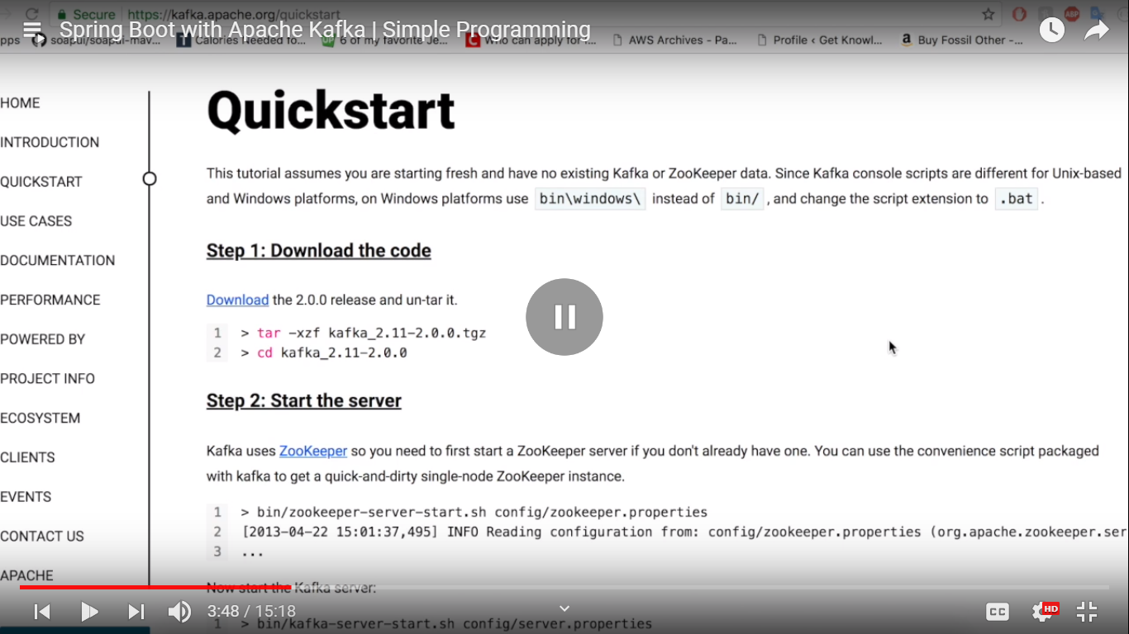

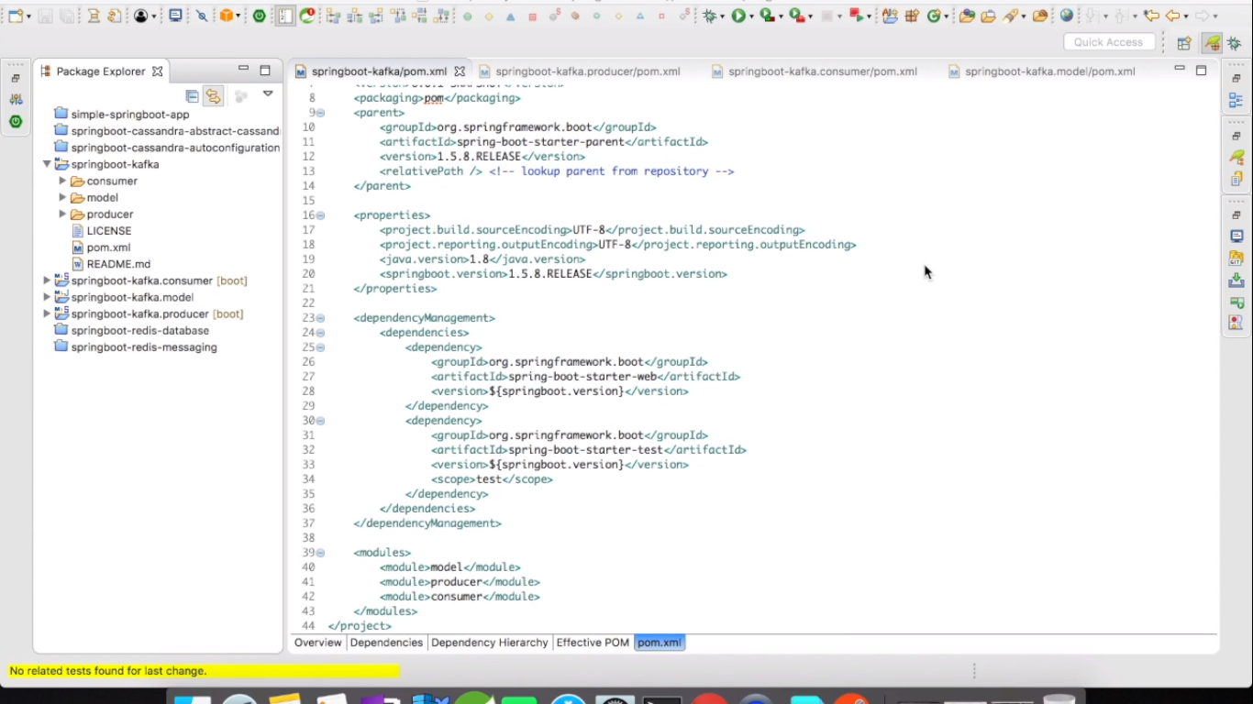

Producer as a separate SBA and consumer as a separate SBA.

When producer sends a request to consumer through kafka, it is going to be 2 different application running in different ports.

We have created a model project because we are going to send the Student object from producer to consumer so that we don’t need to create a Student.java file in producer and Student.java file in consumer. We want to have Student.java common for both the projects.

4 projects

1. Springboot-kafka

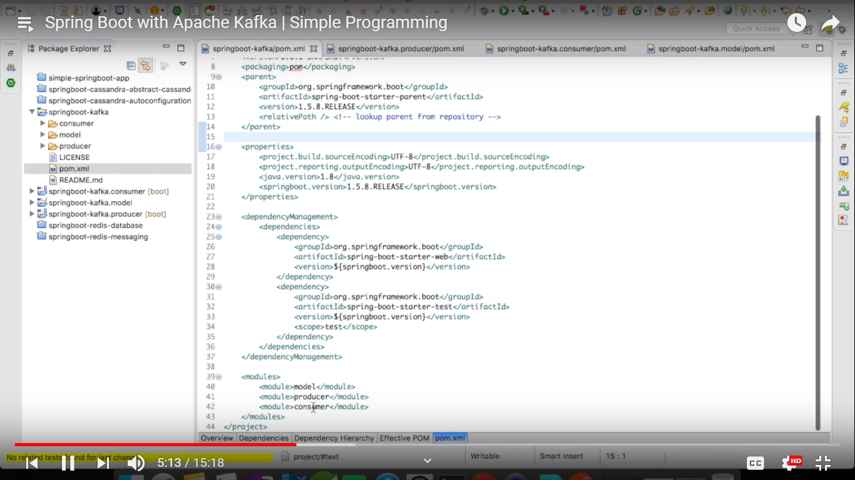

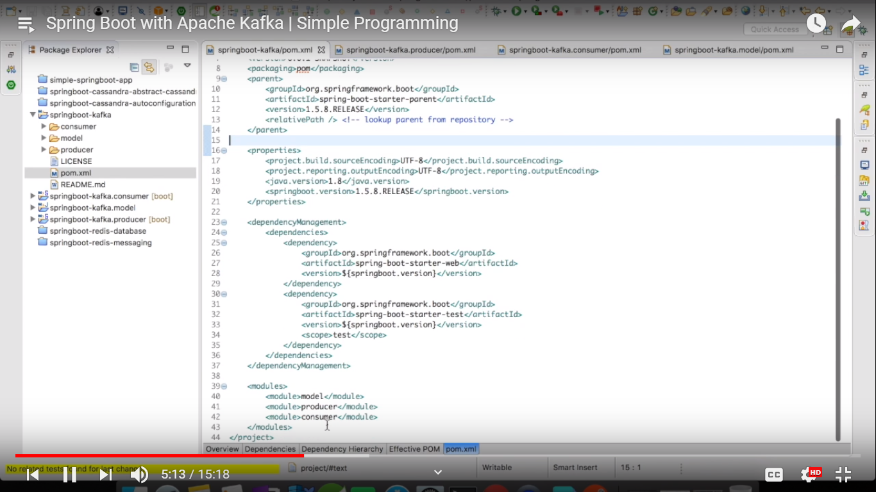

1. Kafka producer

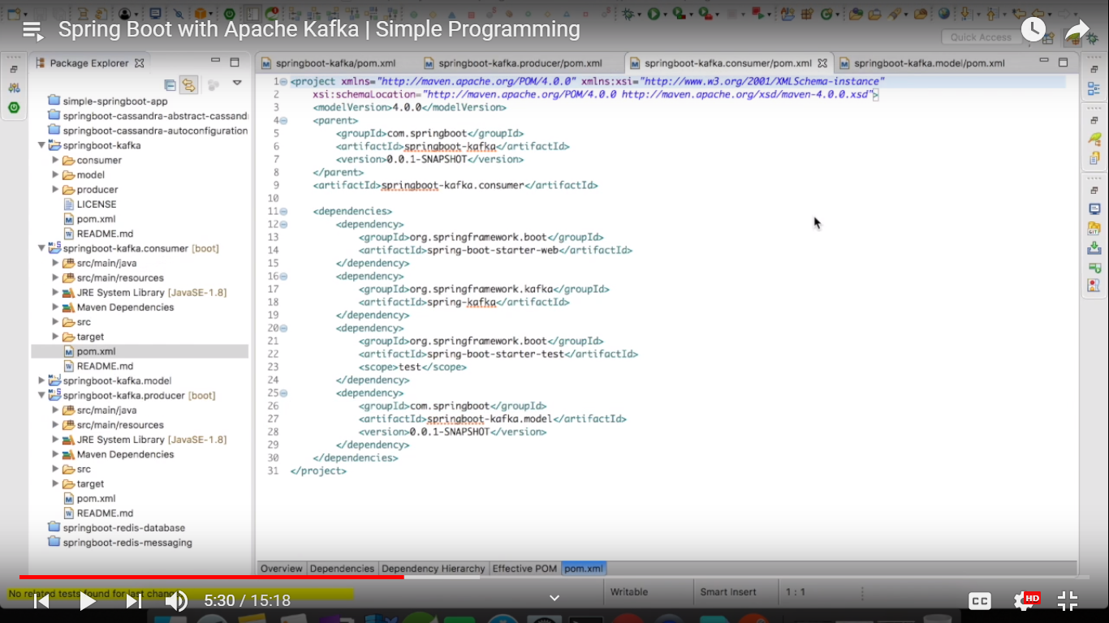

1. Kafka consumer

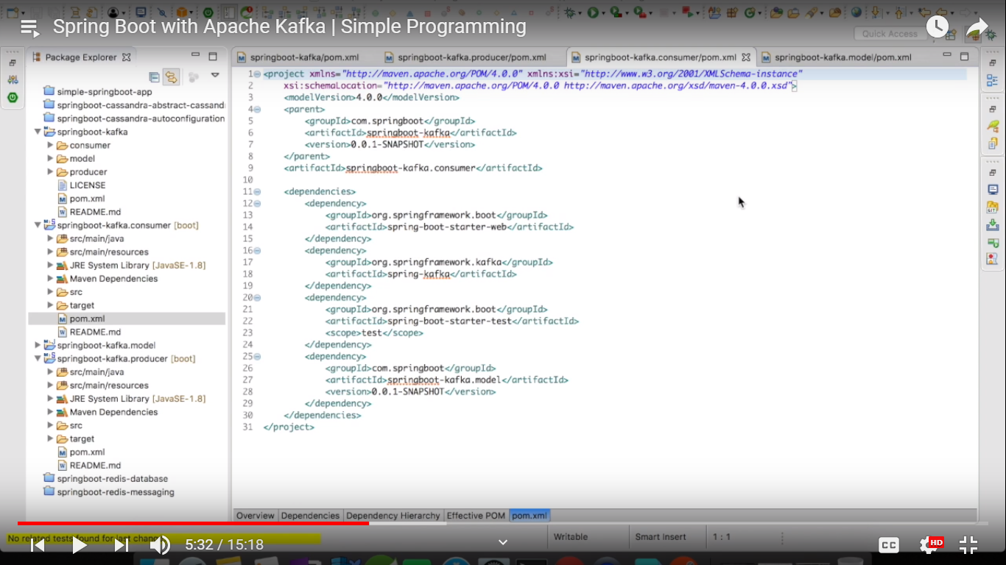

1. Kafka model

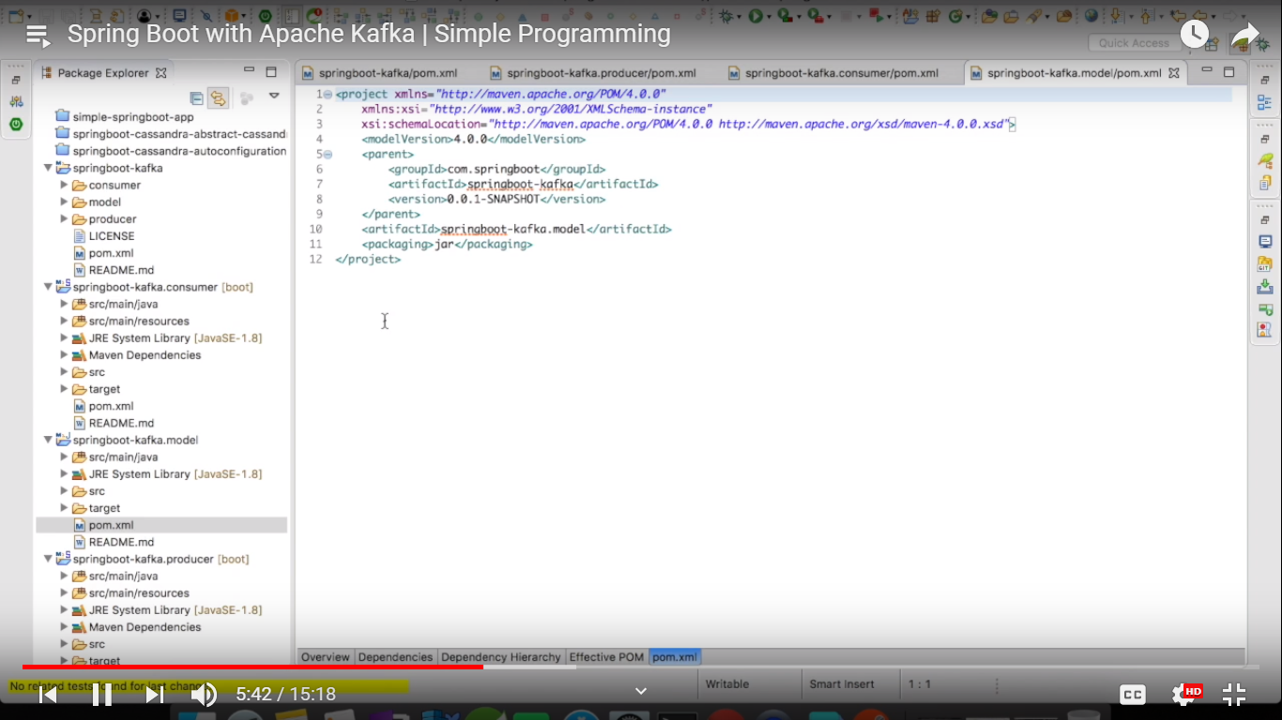

Now in producer

We can use kafka in spring boot application in 2 ways

1. Auto configuration (as I did using Kafka template directly)
2. Manual configuration (will do here, for production it is always recommended to use manual configuration)

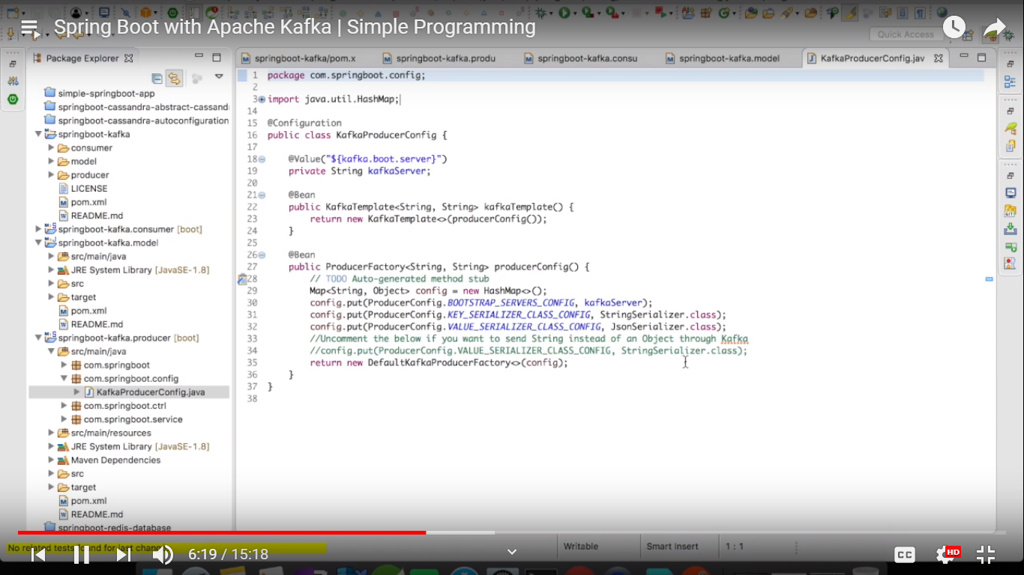

@Bean ProducerFactory is needed to enable transaction in Kafka.

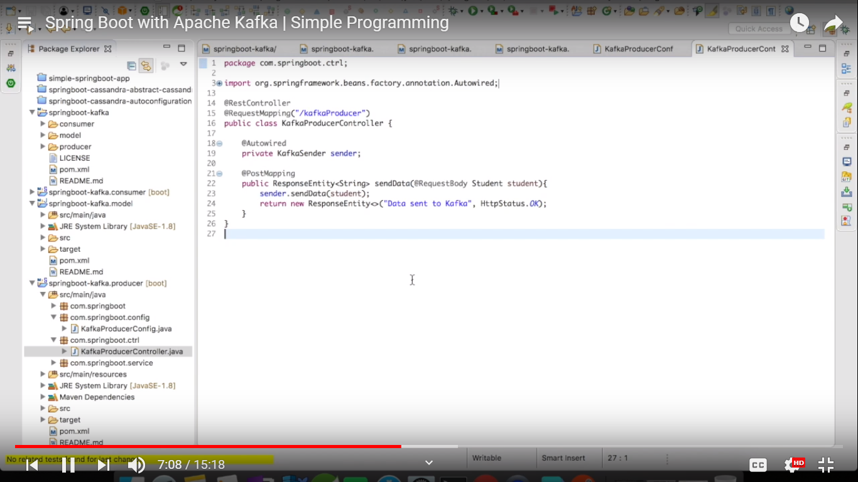

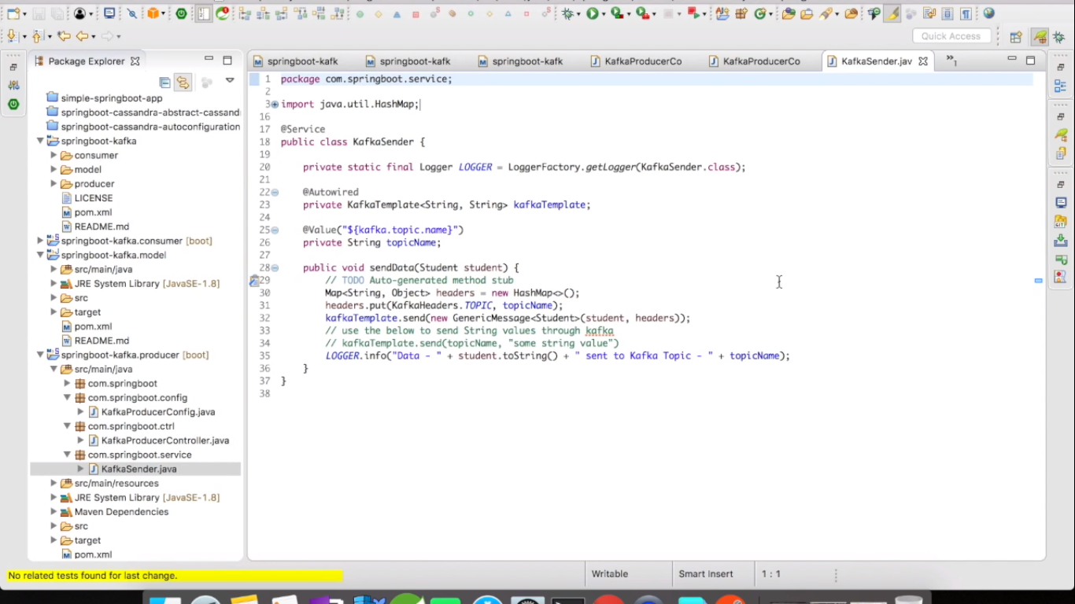

We will create consumer now

JsonDeserializer to convert a JSON object to Student object.

@KafkaListenerContainerFactory to listen to the messages sent from the producer.

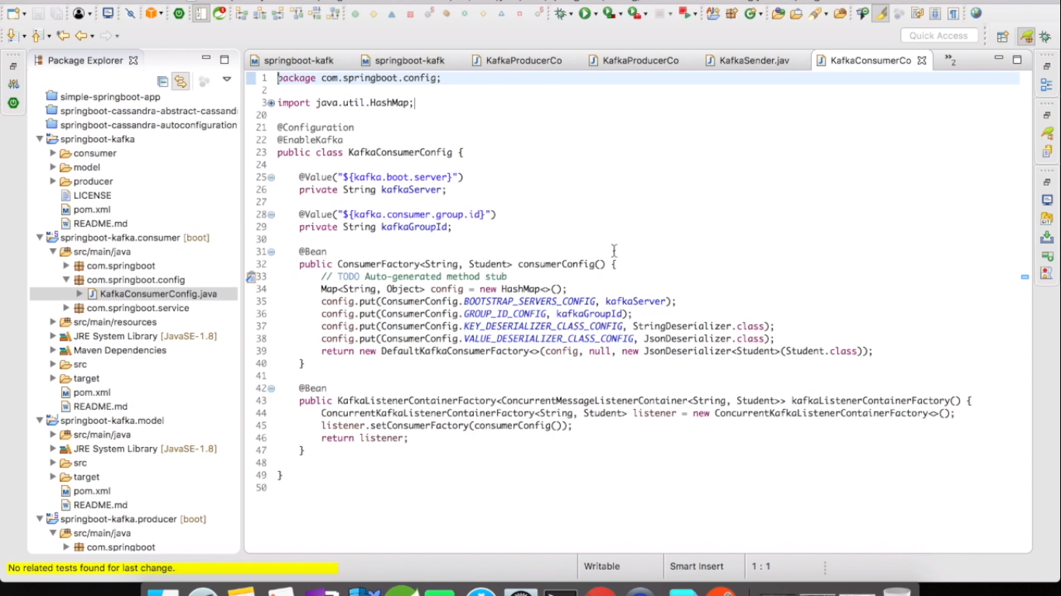

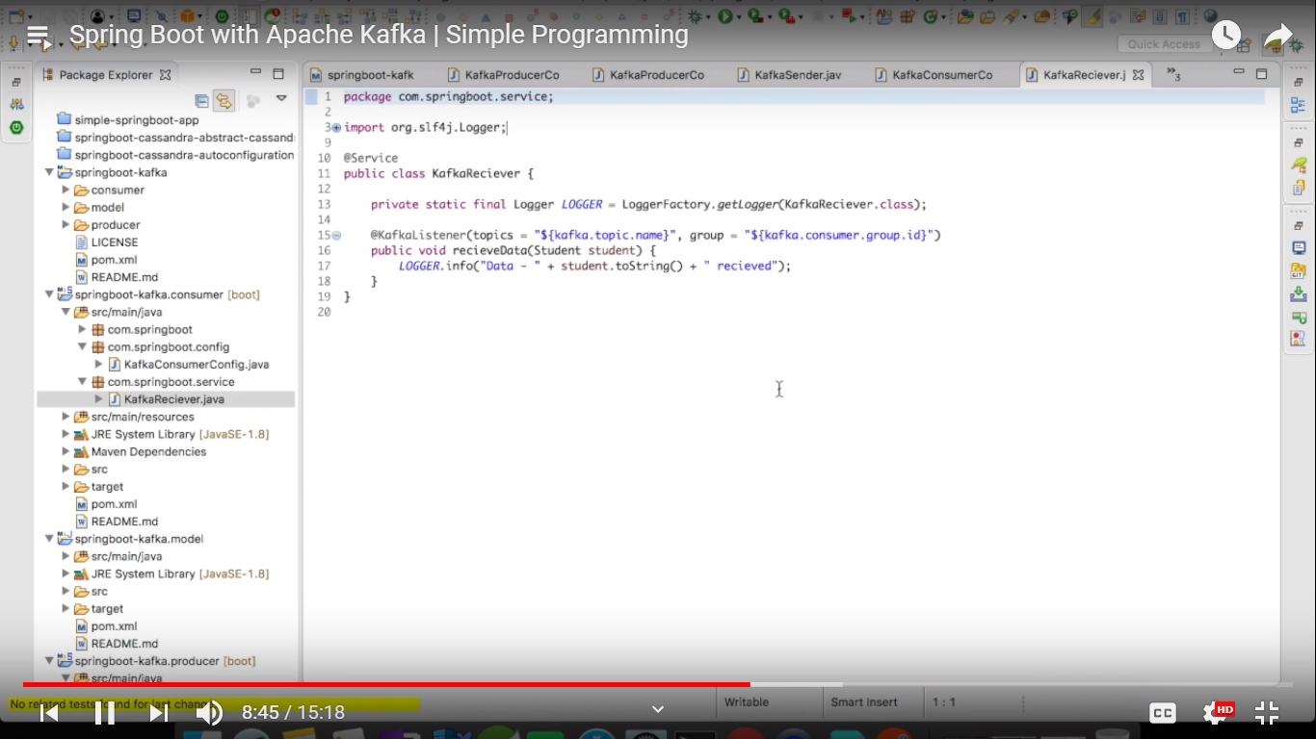 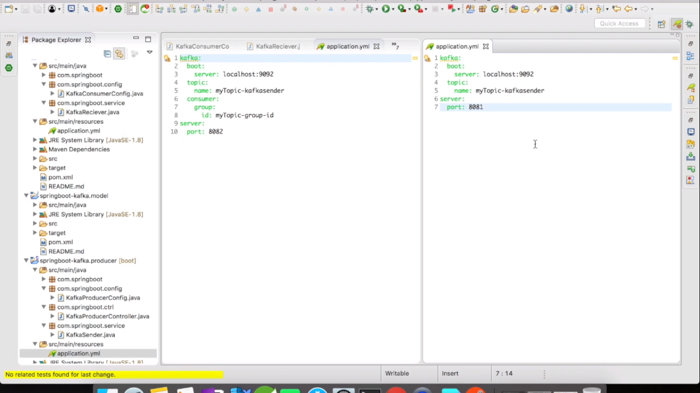

We will look into zookeeper.properties and server.properties

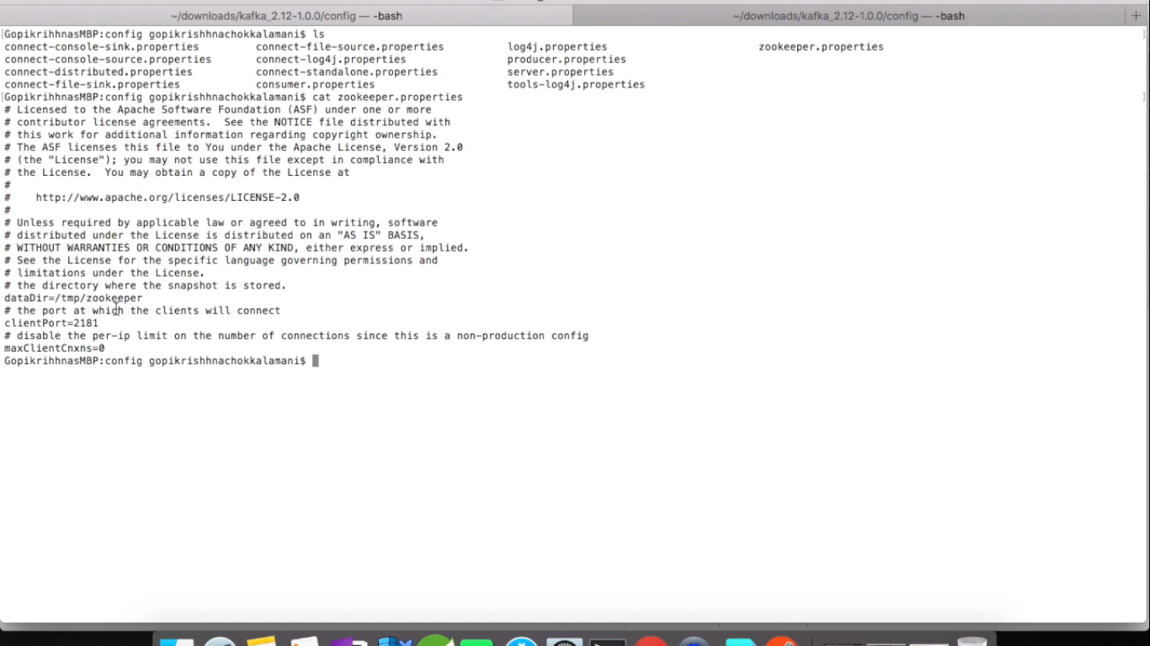

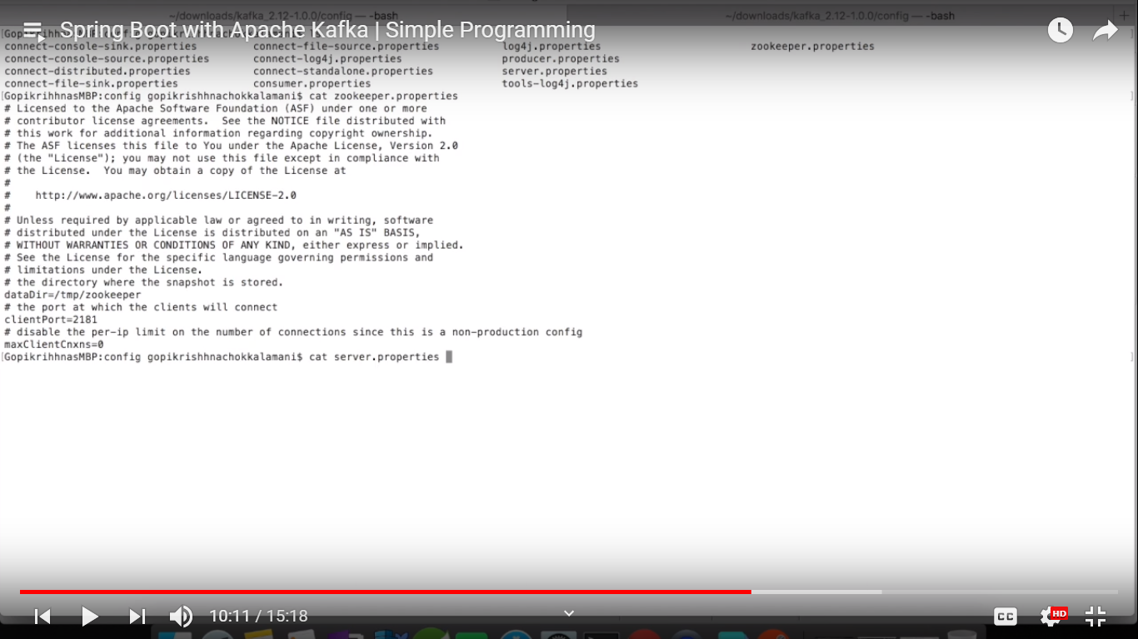

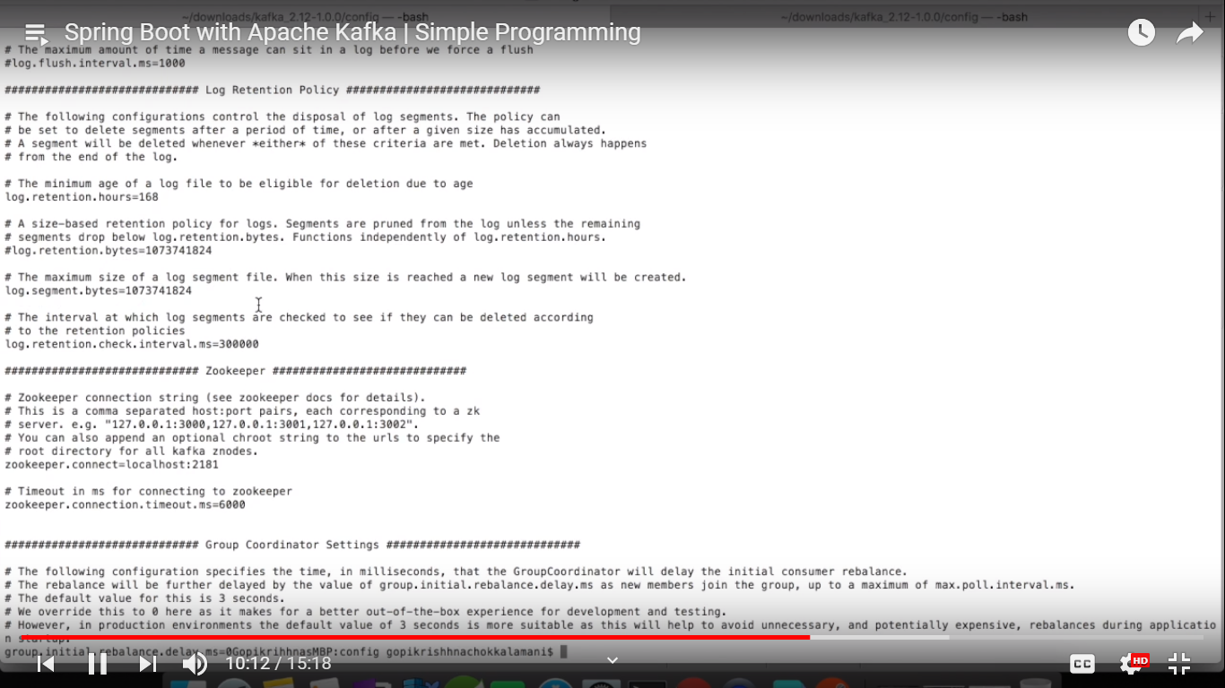

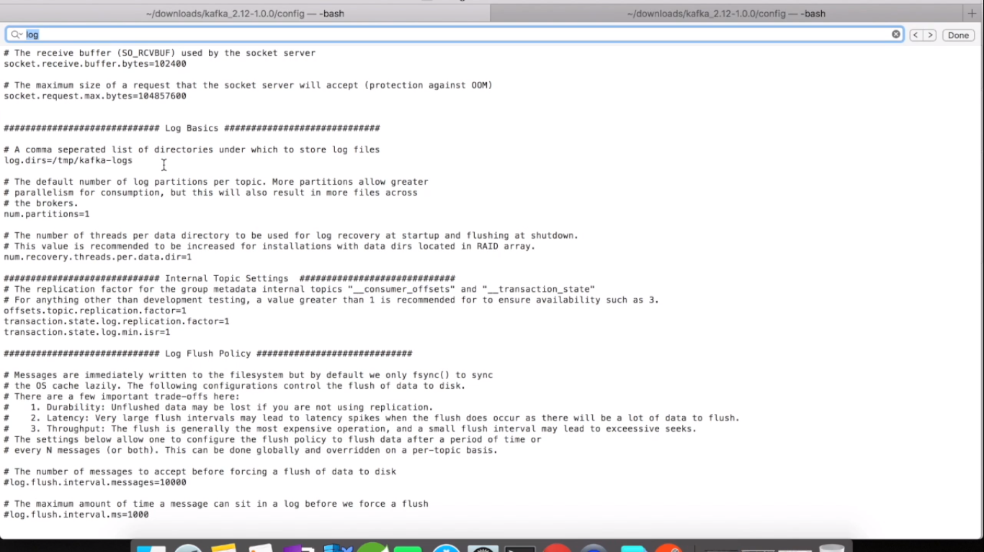

For multi clustering create server-node1.properties, server-node2.properties, server-node3.properties and so on.

Start zookeeper

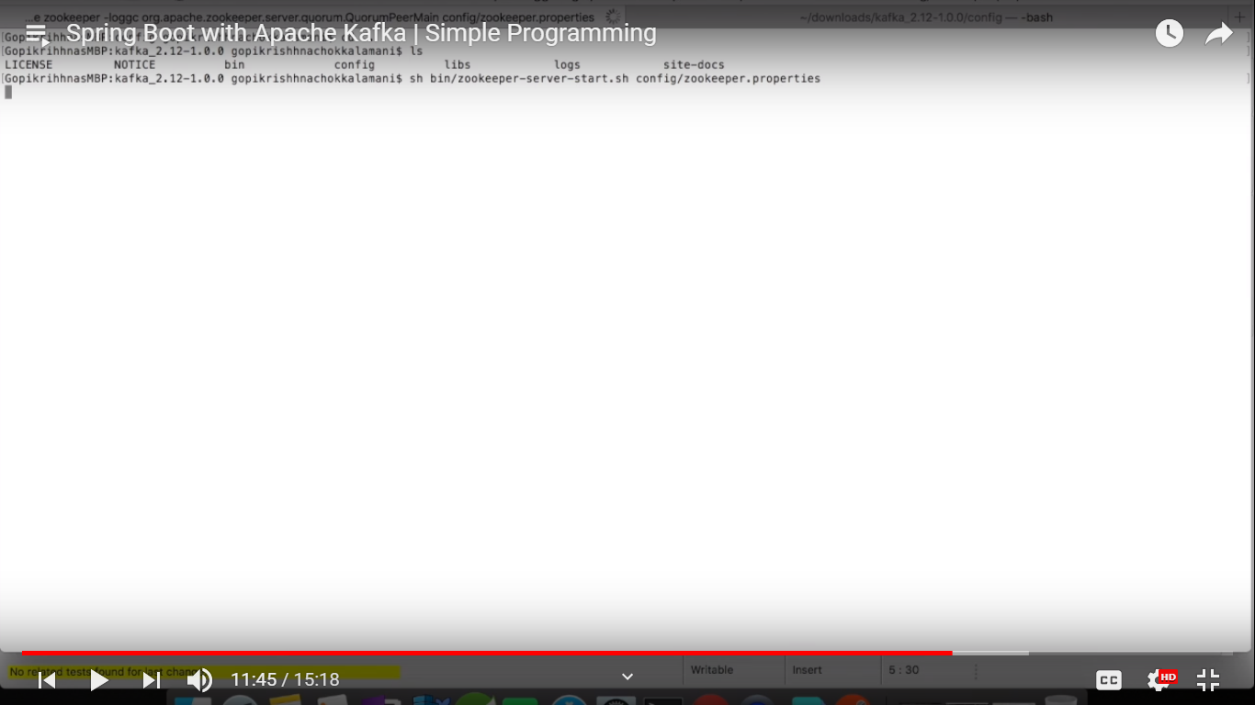



Start kafka server

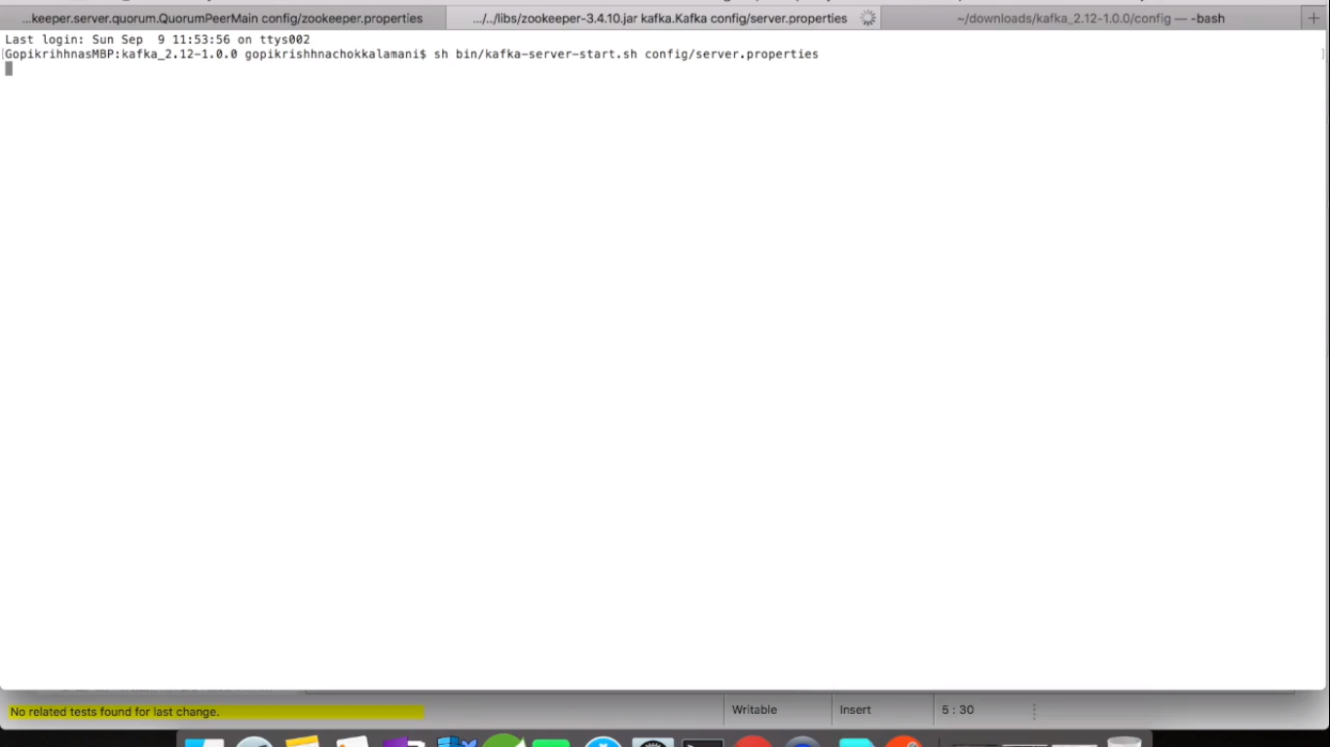

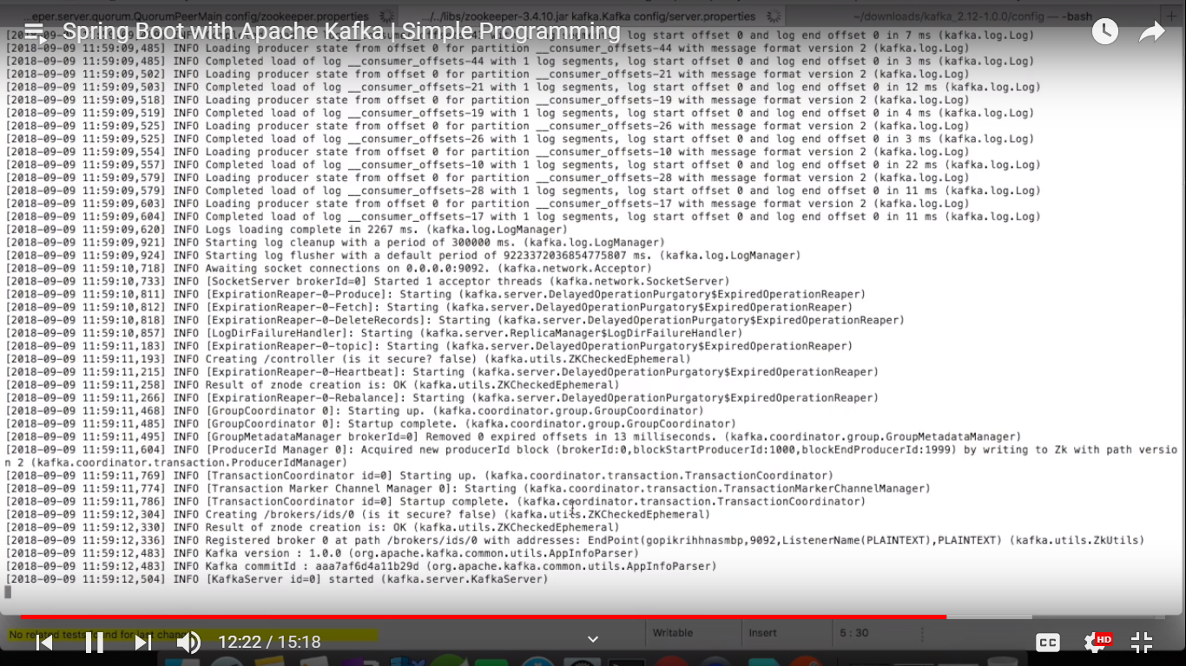

Now in code

Start producer and consumer

We will get the below when our SBA is registered to Apache Kafka server

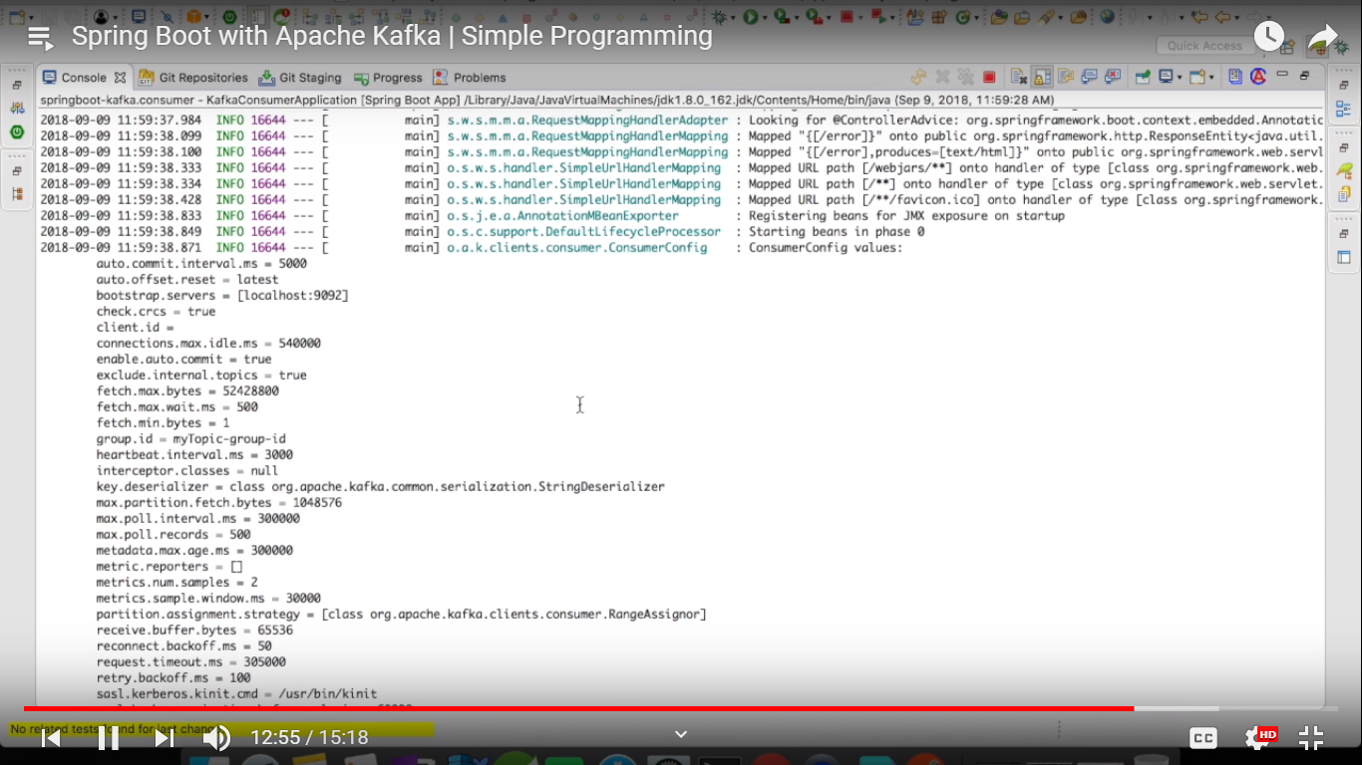

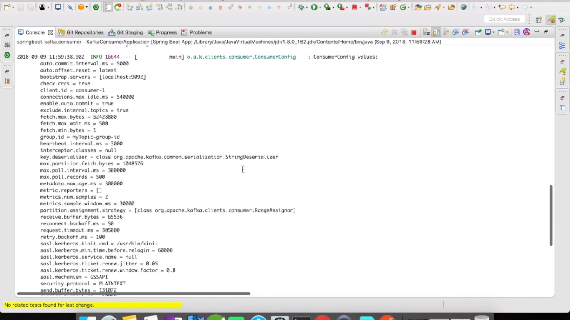

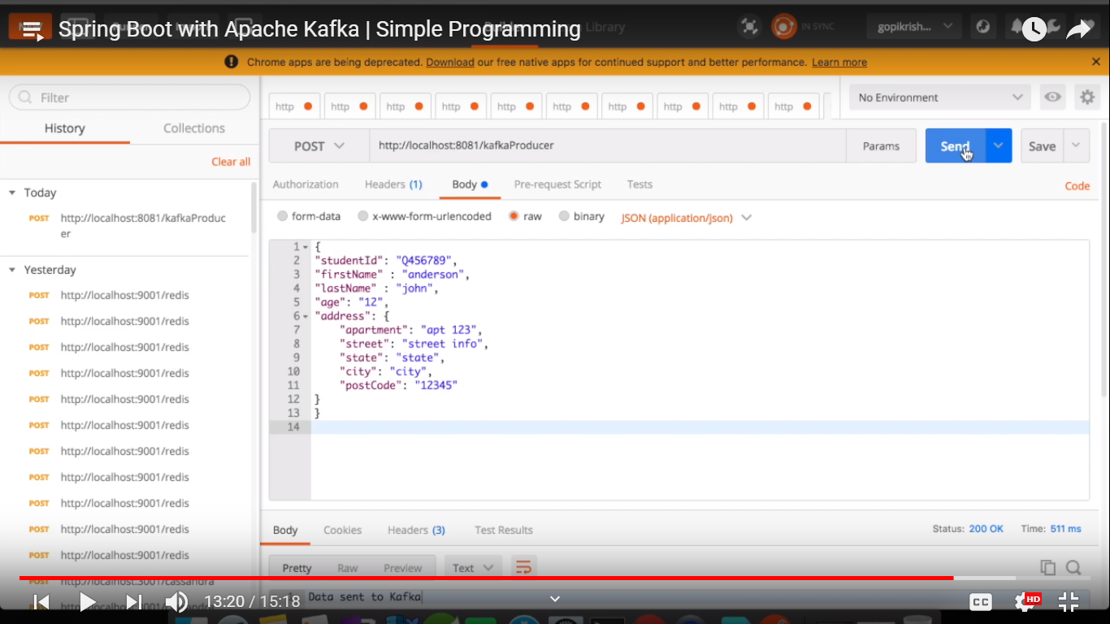

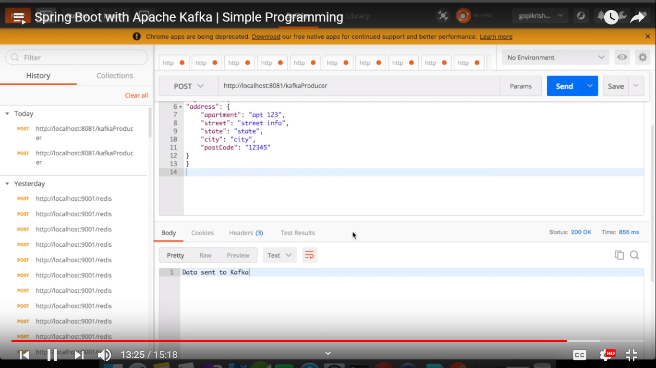

Kafka consumer console

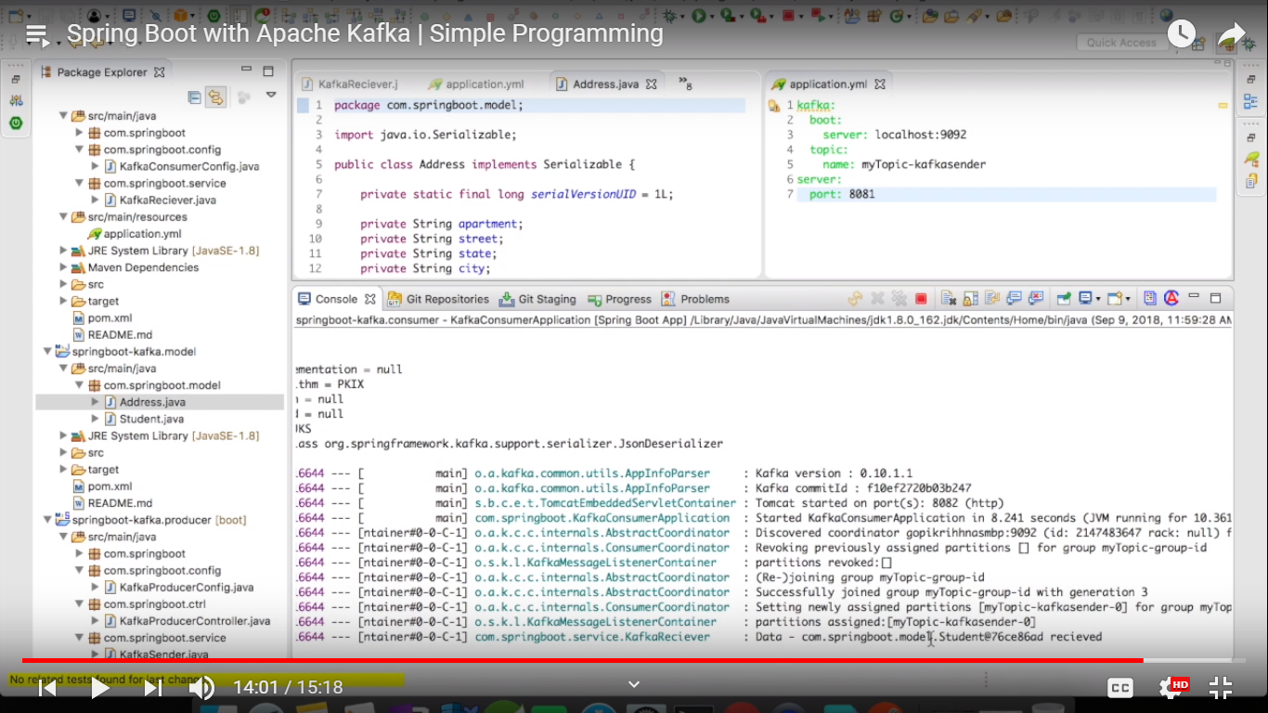

How data is stored in the zookeeper

